Project Statement of Work

|  |  |
| --- | --- |
| **Team Members:**  Adam Ford  Allan Juarez  Axel Zumwalt  Harrison Majerus |  |
| **Team Name:**  Team 1 |  |
| **Lab Section:**  E |  |
| **TA Approval:** | “Yes” -Omar |

Refer to the ESI Project Requirements document before completing this Statement of Work (SOW). Teams should complete and submit this SOW form, which represents several parts of a statement of work, including a plan for what you are doing and how. The SOW defines the scope of your project and the approach you are taking to deliver on the goals.

# Problem Statement

First, review and elaborate on the broad mission goals of your AV application using the memo your team wrote earlier. The mission goals and user needs establish the purpose of the project and why you are working on it. Now you should translate these into a more detailed problem statement that provides a clear description of the context for the problem, an explanation of user needs that will be addressed, and an outline of your proposed technical approach to solving the problem. In addition to writing a paragraph or two about the problem, you are to draw a one-page sketch illustrating your solution with a user context (big picture view). This should show the scope of your work in relation to one or more user needs.

The problem statement should provide a specific, concise, clear, and thorough description of the context for your mission goals. The statement must be understood and considered relevant by division managers. It should mention a specific user (or user group), their need(s), and their reason for having that need. The need and reason must be supported by your prior user research.

|  |
| --- |
| **Problem Statement**  The greens at the local golf course are very unkempt as Tiger Wood’s marriage. The Masters are coming up and Phil Mickelson wants his greens to be spotless. The course is understaffed and has decided to use an automated, robot to perform this task and save time and money.  The maintenance staff at the course wants the robot to be placed anywhere on a hole, and navigate to the green where it can begin cleaning. On its way to the green, the robot must be able to detect and avoid any obstacles as to not disturb the nature or golf players. It should also detect drops in elevation so that it doesn’t fall into a sand trap or pond.  Once it has reached the green, the robot will blow off any debris and relay back to maintenance command, that the green is clear. |

# Design Approach

Next, consider your AV application in relation to the project requirements and the five categories by which it will be evaluated.

1. Functionality in relation to the AV application mission goals and user needs
2. Mapping of functional requirements to platform components and capabilities
3. Elements of the test field
4. Serious incident penalties
5. Feature bonuses

In this section, you will identify and describe how you will design your application for each of these categories.

In addition to completing the tables below, you are to draw a one-page sketch depicting a high-level technical system diagram of your proposed solution, such as a block diagram or dataflow diagram. This should show both hardware and software modules.

**The tables below are your initial proposal, and you may update these before your demonstration.**

## Functionality

Describe each of the basic functionalities required for the project in terms of your AV application. The functionality should be specific to the problem and user(s). Several functional statements are given in the example functional description for the Mars rover application in the Project Requirements document.

|  |  |
| --- | --- |
| **Basic Functionality** | **Mapping to AV Application** |
| Cybot Communication | Telling the robot to start navigation, getting confirmation that the robot is in the green, receiving message after the green is cleaned, and getting constant metadata regarding object detection at the base station. |
| Cybot Movement | Robot should drive through the golf course on its way to the green, avoid obstacles and sand traps by driving around them. Once in the green, it drives in a circle “blowing” any debris. |
| Object Detection | Detects objects on the fairway like trees and golfers to avoid. Detects the green by recognizing 3in pillars on each corner. |
| Object Avoidance | Avoids detected obstacles on the fairway by either backing away from them or driving around them. Also utilizes sensors to prevent falling into a sand trap or pond. |
| Boundary Adherence | Stays on the fairway and green by checking ground for a boundary and staying out of the rough. |
| Arrival at Destination | Drives into the green and senses the flags around the green to confirming that it is in the right position. Spins around to sweep the green clear of debris, and sends confirmation to base station. |
| User Interface | Displays current status of the robot, metadata for the objects its detecting, and options for manual control. |
| Base Station Control | Ability to start, stop, and idle the robot and preform manual operations like scanning, moving, and cleaning. |
| **Other Application Specific Functionality (may be novel features for bonus points)**  Makes a celebration sound at arrival.  Spins around the green after arriving. | |

## Mapping to Platform

Briefly describe how each of the basic platform components required for the project will be used in your AV application.

|  |  |
| --- | --- |
| **Basic Platform Components** | **Usage in AV Application** |
| Open Interface and iRobot Sensors | Moving the robot, detecting drops, rough boundary, and green boundary. |
| Interrupts | Bumping into objects, detecting drops, detecting rough bounds so that program can avoid hazards and adjust appropriately at any point. |
| ADC | IR sensor to measure linear distances, which can be used to determine drive distances. |
| Input Capture | Ping))) sensor to measure radial distances, and detect objects close by. Use to determine location of objects to orient the robot, and then drive or use IR sensor for distance measurement. |
| PWM | Servo movement works in conjunction with IR and Ping))) sensors to direct them. |
| UART/WiFi | Establish a connection with base station so that data can be sent, and control instructions can be received. |
| **Other Platform Components or Modes (may be novel features for bonus points)**  Plays the song. | |

## Elements of the Test Field

Briefly describe a test field in the context of the real application (e.g., Martian terrain, city streets, etc.). Then state what each of the basic objects and other elements required for the test field represent in terms of the AV application. Draw and attach a sketch of a possible simple test field for the lab.

|  |
| --- |
| **Test Field Description** |

|  |  |
| --- | --- |
| **Basic Objects and Other Elements** | **Mapping to AV Application Test Field** |
| Tall objects | Trees |
| Short objects | People, golfers, golf balls |
| Holes | Sand traps, ponds |
| Pillars | Edge of Green (Fringe) |
| Out of bounds | Rough |
| Destination zone | Green |
| **Other Application Specific Elements (may be novel features for bonus points or incidents to avoid)** | |

## Serious Incidents to Avoid and/or Novel Features (Optional)

You may have identified novel features in the tables above. Enter them in the table below and propose possible bonus points if demonstrated successfully. In addition, describe any additional serious incidents that might happen in your test field for your AV application.

|  |  |
| --- | --- |
| **Novel Features**  Cleans around the green, plays a song.  Green cleaned before Masters (dead week). | **Bonus Points**  +2  +5 |

|  |  |
| --- | --- |
| **Serious Incidents**  Falls in a sand trap, gets stuck in rough, hits a person. | **Deductions**  -5 |

## Sketches

Attach the following sketches to your submission.

* **Problem sketch**
* **Test field sketch**
* **Technical system sketch**

Problem Statement:

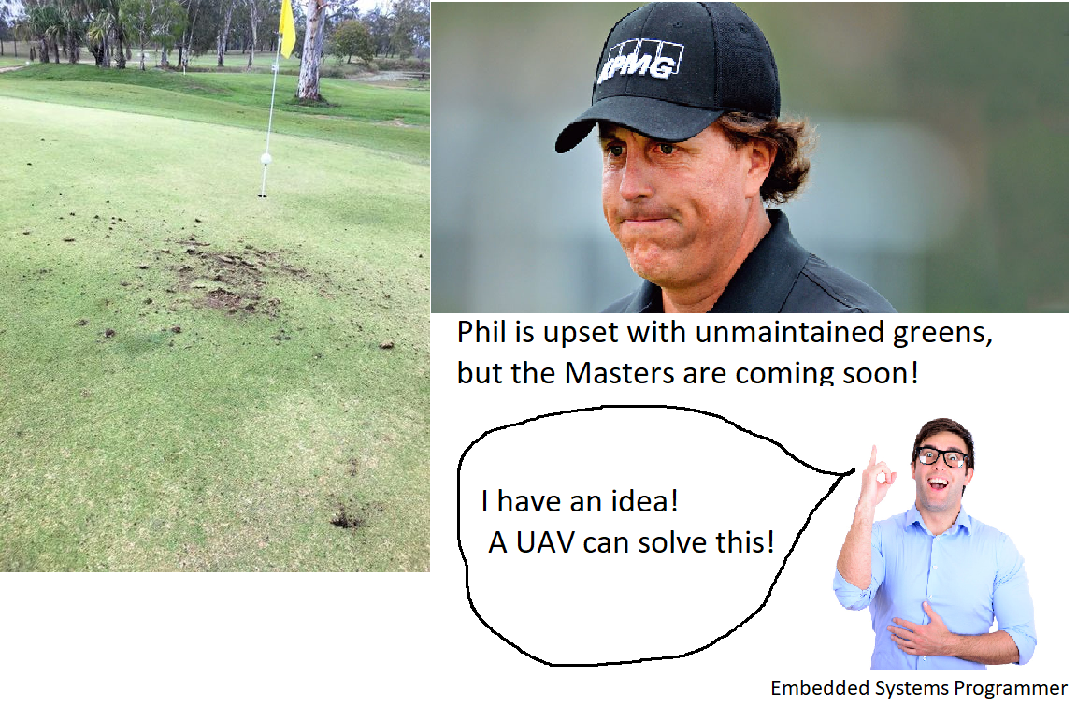

Technical System Sketch:

